APEXFORMZ V2
  - Product Requirements Document
Modular human motion intelligence
and sport expert engines
A shared motion foundation for independently evolving sport and movement analysis, real-time coaching, and athlete progression.

Foundation release focus
Migrate the existing Taekwondo pipeline into isolated engines, preserve responsive feedback, and establish trustworthy scoring, reference data, and versioned results.
Document control | Value
Product | ApexFormz / SmartCoach
Version and date | 2.0 | September 2026
Document status | Master Product and Engineering PRD
Review audience | Product, engineering, data, quality, and coaching
Product and technical owners | To be assigned
Release date and approvers | To be assigned

Decision required
Confirm foundation scope, assign ownership, and resolve the acceptance and contract decisions listed in Section 20. Proposed additions are identified throughout the document.

Contents
01 Product overview 3
02 Scope and priorities 4
03 Users and experience 5
04 Existing platform and migration baseline 6
05 Target architecture 7
06 Perception and human motion 8
07 Sport and movement engines 9
08 Phases and reference retrieval 10
09 Reference data governance 11
10 Shared analysis and scoring 12
11 Coaching and confidence 13
12 Training flow and failure handling 14
13 Real time performance 15
14 APIs and integration 16
15 Persistence and athlete intelligence 17
16 Session state and operations 18
17 Migration and rollout 19
18 Validation and success metrics 20
19 Release acceptance 21
20 Risks and open decisions 22
Appendix A Motion contracts 23
Appendix B Session and result contracts 24
Appendix C Package and code organization 25
Appendix D Illustrative policies and glossary 26

Reading guide
Sections 01–05 establish the product and architecture. Sections 06–16 define requirements and operations. Sections 17–20 cover migration, validation, acceptance, and open decisions. Appendices retain engineering contracts and illustrative configurations.

01 Product overview
ApexFormz V2 establishes a modular sports coaching platform built on a shared Human Motion Engine and independently managed Sport and Movement Expert Engines. The foundation release migrates the existing Taekwondo analysis into this structure while preserving real-time feedback, the application stack, authentication, and training engagement features.
The architecture separates body measurement from sport interpretation. A joint configuration may look similar in a badminton smash, a tennis serve, or a cricket throw, yet require different phase definitions, reference examples, scoring weights, and coaching. V2 must prevent data or rules from one sport from influencing another sport’s analysis.

Product objectives
- Establish a sport-neutral motion representation with consistent geometry, timing, confidence, and optional depth data.
- Restrict analysis to the selected sport, movement, and phase, with independent reference datasets and scoring policies.
- Reuse proven analysis capabilities through shared services instead of duplicating motion mathematics in each sport package.
- Preserve responsive live feedback while keeping expensive post-repetition models outside the live frame path.
- Make a new sport primarily a package, configuration, reference-data, and validation effort.
- Store structured repetition results that can support athlete trends and personalized coaching over time.

Outcomes and evidence
Outcome | Evidence required
Domain isolation | Automated tests record zero access to reference repositories belonging to unselected sports.
Extensibility | A second sport uses the engine interface without sport-specific changes to the Human Motion Engine.
Responsive coaching | AI latency meets the stated P50 and P95 targets; live feedback is measured end to end.
Reproducible analysis | Results retain movement and reference versions; richer engine and policy provenance is progressively added.
Trustworthy feedback | Low-confidence analysis abstains or reduces specificity; unavailable AQA never produces a fabricated score.

Intended readers and use
Product, engineering, data, and coaching reviewers use this PRD to align release scope, implement interfaces, prepare datasets, and evaluate acceptance evidence. Taekwondo is the reference implementation. Badminton is the recommended candidate for the second sport; that selection remains open.
Requirement language. “Must” and “shall” identify requirements within the stated delivery phase. “Should” identifies a recommendation. Items marked “Proposed” expand product or operational detail and require review before becoming commitments. Numerical examples illustrate contracts or policies and are not validated thresholds. P0–P3 describe priority, not delivery dates.

02 Scope and priorities
The foundation release focuses on architectural isolation and reliable migration. Structured rep data prepares for personalization, while trend-based coaching and a second native sport remain subsequent work.
Priority | Capability | Scope
P0 | Shared motion core and contracts | Normalize motion, preserve z, centralize confidence and filtering, define engine interfaces and registries.
P0 | Reliability | Handle unavailable AQA, session lifecycle, version diagnostics, and bounded frame processing.
P1 | Taekwondo migration | Package current movements, phase definitions, references, models, and movement scoring.
P1 | Dataset architecture and validation | Introduce manifests, immutable versions, phase labels, expert metadata, golden datasets, and coach review.
P2 | Athlete intelligence | Add recurring-issue tracking, movement profiles, consistency, and progression metrics.
P2 | Second sport | Prove extension through the plugin interface; badminton is a candidate.
P3 | Recognition and equipment | Add confidence-gated sport or movement classification and optional object perception.

Initial V2 boundaries
Initial input sources are webcam and uploaded video. The browser MediaPipe implementation remains the default perception path. Users explicitly select sport and movement. Existing static and dynamic analysis must continue to operate during migration.
The initial migration does not require replacing MediaPipe, Next.js, Node/Express, or FastAPI; rewriting gamification; training one universal sports model; recognizing every sport or movement automatically; supporting multi-person tracking or native mobile apps; automating coach certification; or tracking all balls, shuttles, rackets, and bats in real time.

Future extension points
Additional capture sources may include mobile, external, and multiple cameras and prerecorded coach footage. Advanced reference indexes may replace brute-force search behind a stable interface. A learned Human Motion Encoder may feed separate sport heads and, where useful, movement heads. This shares motion representation while preserving sport-specific decision boundaries.
Future object perception may expose a TrackedSportObject containing type, position, optional velocity, and confidence. Sport packages may declare optional or required equipment observations. These interfaces are extension points, not initial equipment-tracking commitments.

03 Users and experience
The primary experience is an athlete selecting a movement, setting up the camera, performing repetitions, and receiving a small number of useful corrections. Coaches and movement specialists define valid references and review the quality of analysis. Engineers maintain shared capabilities and add isolated sport packages.

Proposed user stories and acceptance detail
ID | User need | Observable acceptance
UX01 | As an athlete, I want to train the movement I selected. | Sport and movement remain visible; session setup validates the selection; feedback identifies the same sport and movement.
UX02 | As an athlete, I want clear camera setup guidance. | Poor tracking produces actionable setup guidance and suppresses precise biomechanical corrections until evidence improves.
UX03 | As an athlete, I want to understand a completed rep. | A rep summary exposes overall score, available components, confidence, and the main detected issues. Unavailable components are identified.
UX04 | As a coach, I want trustworthy reference material. | Dataset records identify movement, version, camera context, annotations, and review status. Published versions are immutable.
UX05 | As an engineer, I want independent sport packages. | Disabling a sport leaves other sports operational; isolation tests and declared feature requirements pass.

Live coaching interface
Preserve the webcam panel, body skeleton, live score, issues, phase, and rep count. Add a sport indicator, movement indicator, and engine state: Ready, Tracking, Movement detected, or Analyzing. Confidence warnings should tell the athlete what to change, such as moving farther from the camera to bring the body into view.
The live display should present one primary correction and no more than one secondary correction. A detailed component breakdown belongs in the rep or session summary. Feedback must stabilize across frames rather than flash after one noisy observation.

Proposed uploaded video journey
The athlete selects sport, movement, dominant side, and camera view, then chooses a video. The interface validates the supported input, shows processing progress, and provides repetition summaries and time-linked issues when analysis completes. Cancellation, unsupported media, and processing failure receive explicit states. File formats, duration and size limits, storage location, and processing-time objectives remain decisions to resolve before delivery.
Video analysis should preserve media timestamps and the same domain and confidence boundaries as live analysis. Define its sampling policy separately; live frame-dropping behavior must not silently determine offline processing.

04 Existing platform and migration baseline
ApexFormz already combines browser pose extraction with real-time orchestration and an AI analysis service. V2 reorganizes these capabilities around explicit ownership boundaries. The baseline described here is the current product architecture to preserve during migration.
Component | Existing responsibilities | V2 treatment
Frontend | Next.js interface, webcam capture, MediaPipe Pose Landmarker, authenticated Socket.IO, skeleton and feedback display | Retain the stack and interaction model; extend session context and result presentation.
Backend | Node/Express authentication, sessions, static or dynamic routing, frame relay, persistence, XP, streaks, leaderboards, and Circles | Retain orchestration and compatibility; preserve newest-frame backpressure and keep-alive connections.
AI service | FastAPI, static pose analysis, dynamic movement analysis, reference matching, scoring, and post-rep inference | Extract shared motion services and route through isolated sport and movement engines.
Shared data | TypeScript types and PostgreSQL persistence | Standardize frame contracts and add structured repetition and version records.

Capabilities to reuse
Retain and reorganize BaseAnalyzer, AnalyzerRegistry, DynamicAnalyzer, PhaseDetector, PyomecaStreamAdapter, the One Euro KeypointSmoother, FrameMatcher, KineticChainValidator, TrajectoryScorer, MovementRegistry, ST-GCN Action Quality Assessment, expert-frame data, and movement blueprints.
DynamicAnalyzer currently coordinates readiness, normalization, filtering, phase detection, scoring, trajectory recording, fluidity, confidence, and overall scoring. It may remain as a temporary adapter while the generic operations move into the core and movement-specific orchestration moves into MovementEngine.

Compatibility constraints
- Keep /analyze and /analyze/dynamic operational during migration.
- Retain session:start, frame:submit, feedback:result, and session:stop events.
- Preserve existing authentication, gamification, social training, and static analysis behavior.
- Keep the frameInFlight and latest pendingFrame strategy; do not accumulate an unbounded queue.
- Preserve current behavior during core extraction and avoid major scoring changes while introducing engine interfaces.
The application services remain apps/frontend, apps/backend, and apps/ai-service. The refactor primarily changes how analysis code, state, configuration, and datasets are organized within those boundaries.

05 Target architecture
The Human Motion Engine owns sport-independent measurements. Sport and Movement Expert Engines interpret those measurements within an explicit context. Shared analysis services execute reusable algorithms with configuration supplied by the selected movement.
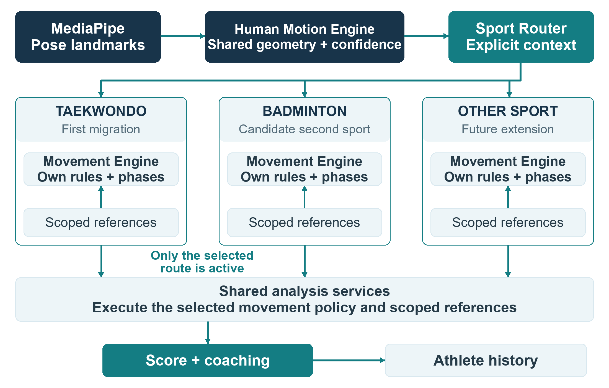
Figure 1 Shared motion processing with isolated sport and movement interpretation

Architectural requirements
ARC01. The core shall expose normalized motion and confidence without sport-specific terminology, reference selection, scoring rules, or coaching conclusions.
ARC02. Only the selected sport and movement may supply references, phase definitions, weights, models, and rules to a session. Shared analysis services must preserve that context.
ARC03. Each sport shall support independent registration, versioning, testing, and disabling. Adding a sport should not change core logic unless a genuinely universal feature is needed.
For example, the core may measure hip and shoulder angular velocity. A badminton movement engine may identify an ordering issue. The Coaching Engine converts that issue into a correction, and the Athlete Intelligence layer later evaluates whether it recurs over multiple repetitions.

06 Perception and human motion
MOT01. The perception layer shall produce timestamps, frame identity, named landmarks, detection confidence, and source width, height, and estimated frame rate. Landmark records contain x, y, visibility, and z whenever the detector provides depth.
MOT02. The Human Motion Engine shall standardize 2D and 3D representation and compute available sport-neutral measurements, with appropriate confidence. An absent depth value must not be silently treated as measured depth.
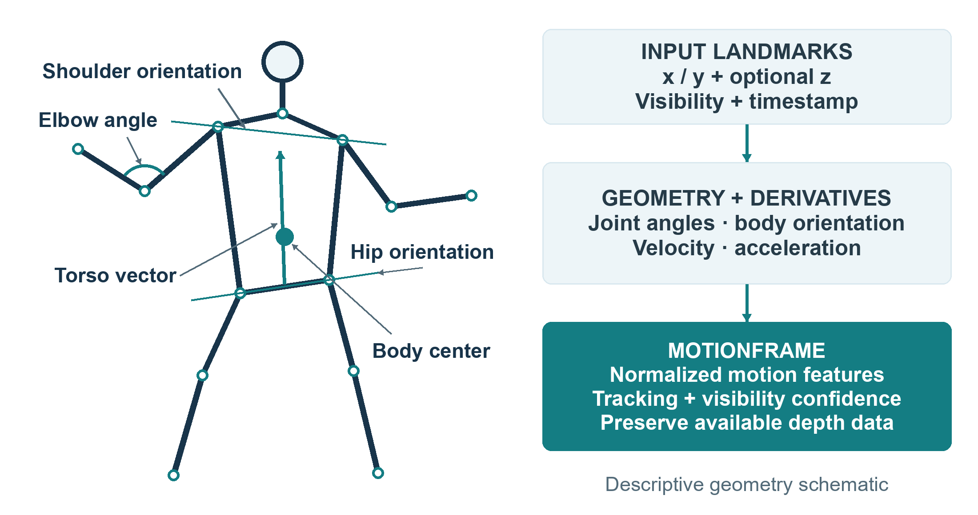
Figure 2 Schematic geometry and motion features derived from pose observations
Feature family | Required capability where technically supported
Geometry | Joint positions; body center; shoulder and hip widths; limb lengths; torso vector; elbow, shoulder, hip, knee, and ankle angles.
Motion | Position and angular velocity; acceleration; angular acceleration; jerk; torso inclination and shoulder or hip rotation.
Temporal and orientation | Activity, history, onset, termination, approximate rep boundaries, body-facing direction, stance direction, and left or right orientation.

MOT03. Centralize One Euro filtering and the optional Pyomeca/Butterworth pipeline, derivatives, and interpolation. A sport-specific smoothing exception requires a documented reason.
MOT04. A Feature Registry shall allow engines to request the features they use. MotionFrame is the common input to sport engines. Coordinate units, feature identifiers, time conventions, and per-feature confidence representation must be resolved in the contract review.

07 Sport and movement engines
ENG01. The Sport Router shall resolve the user-selected sport through SportEngineRegistry. Only that engine participates in scoring. Explicit movement selection is the initial default within the selected sport.

Ownership boundaries
Layer | Owns | Excludes
Sport Engine | Terminology, movement inventory, sport rules, reference datasets, allowed phase models, classification extension, score policies, sport coaching, models, and equipment requirements | Generic landmark extraction, angle mathematics, signal filtering, authentication, and persistence
Movement Engine | Movement phase model, required features, reference constraints, feature weights, kinetic chain, scoring policy, rep analysis, and coaching rules | Reference or rule access outside its sport and movement
Shared services | Reusable phase, matching, trajectory, kinetic-chain, fluidity, and AQA implementations | Global assumptions that impose one sport’s interpretation on another

Engine interfaces
The SportEngine interface provides supported_movements(), create_session(config), classify_movement(motion_window), get_movement_engine(movement_name), and required_features(). The classification method is an extension point; manual-only engines need a documented unsupported result until automatic recognition is introduced.
MovementEngine provides movement_id, required_features(), process_frame(motion_frame), detect_phase(motion_frame), score_frame(motion_frame), complete_rep(), and generate_analysis().
ENG02. Movement engines shall be able to use shared analysis modules without assuming a universal scoring formula, phase sequence, joint-weight table, or model.

Context and future recognition
ENG03. Store dominant side as left, right, or unknown. Mirroring must be movement-aware. A left-handed execution is not automatically interchangeable with every right-handed reference condition.
ENG04. Sessions should identify camera view. The proposed directional vocabulary is front, front-left, left, rear-left, rear, rear-right, right, front-right, or unknown. Legacy “side” labels need an explicit mapping.
Future automatic sport or movement recognition must return confidence and support an uncertain state. It must not silently route ambiguous input. Recognition thresholds are not specified by this PRD and require calibration.

08 Phases and reference retrieval
REF01. Reuse the finite-state-machine PhaseDetector as a configurable framework. Each movement owns its phase definition and transition logic; the shared framework must not impose one universal phase model.
Example movement | Illustrative phase sequence
Badminton smash | Ready → Preparation → Loading → Acceleration → Contact → Follow-through → Recovery
Taekwondo kick | Stance → Chamber → Extension → Rechamber → Return

REF02. Reference retrieval shall constrain sport, movement, and current phase before nearest-neighbour comparison. Compatible camera view, dominant side, and athlete-profile range may further constrain retrieval.
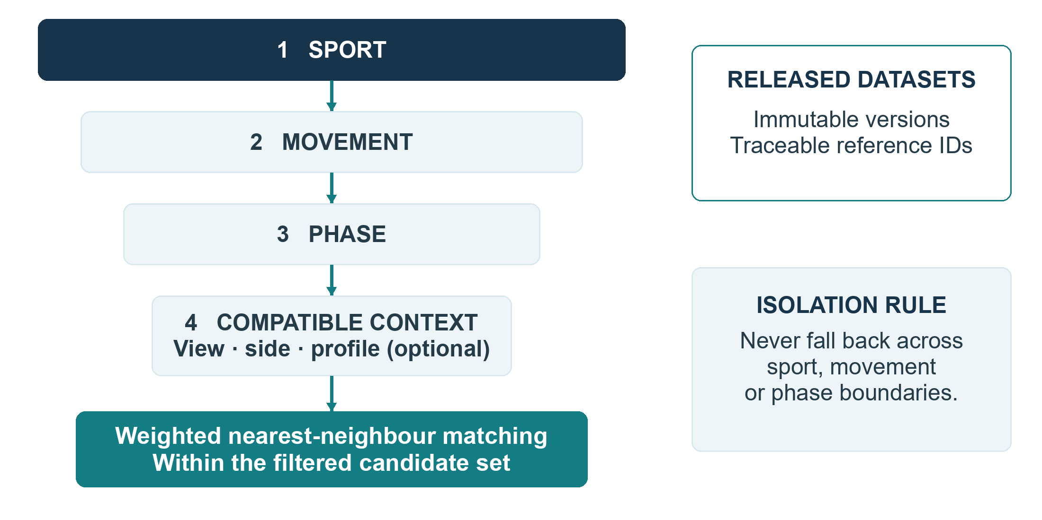
Figure 3 Reference selection narrows the comparison domain before similarity search

Retrieval behavior
An athlete in the acceleration phase of a badminton smash must be compared with acceleration references for that movement. Search must not widen into other sports, movements, or phases to obtain a convenient match.
Proposed clarification. If the eligible reference set is empty or unusable, return an explicit unavailable comparison state. Preserve measured motion and tracking guidance, and withhold reference-dependent scores until valid evidence exists.
REF03. Begin with a BruteForceIndex behind a stable search interface. KDTree, HNSW, or FAISS may replace it as scale requires. Movement engines should not depend on the indexing implementation. Measure reference-search latency before selecting an optimization.

09 Reference data governance
DAT01. Every movement dataset shall have a manifest and an immutable release version. Sessions must record the dataset version used to produce their scores. New data or labels produce a new version rather than changing a released dataset in place.

Organization and metadata
Organize reference data by sport and movement, with compatible camera views and phase indexes. A movement dataset may include manifest.json, view-specific recordings or frames, phase_index.json, trajectories.json, and phase_centroids.json.
Metadata group | Required or planned content
Dataset identity | Sport, movement, version, camera views, dominant sides, and phase vocabulary
Dataset inventory | Athlete and recording counts; sample and recording identifiers
Expert quality goals | Anonymized athlete ID, expertise classification, recording camera, movement type, dominant side, and recording quality
Review and labels | Valid or invalid sample label, phase annotations, coach approval, and reference confidence

Expert quality controls are a development requirement for a trustworthy reference program. The presence of an “expert” video alone does not make it a canonical reference. Counts in illustrative manifests, such as 18 athletes and 91 recordings, are examples rather than dataset size commitments.

Proposed publication workflow
1. Ingest recordings with sport, movement, view, dominant side, and contributor metadata.
2. Check recording quality and landmark visibility, then annotate phases and execution quality.
3. Have a qualified coach review the intended biomechanical interpretation and disputed labels.
4. Build the reference indexes and run golden-set, isolation, and regression evaluations.
5. Publish a versioned manifest only after review; retain the prior release for reproducibility and rollback.

Feature design
DAT02. Reference vectors should support angles, angular velocity, body orientation, hip and shoulder rotation, torso lean, relative landmark geometry, and center displacement. Each movement defines relevant features and weights. Do not limit the architecture to the current set of eight angles.
Proposed clarification. Dataset and feature-schema compatibility should be checked before a session starts. Publication criteria, review ownership, annotation agreement, and permitted reuse of recordings remain open decisions.

10 Shared analysis and scoring
ANA01. Shared analysis services shall be reusable by movement engines while accepting movement-specific feature selections, parameters, and policies.
Service | Responsibility | Movement-specific input
ReferenceMatcher | Weighted nearest-neighbour comparison inside the allowed reference domain | Features, weights, sport, movement, phase, and optional context filters
TrajectoryScorer | Dynamic Time Warping comparison of athlete and reference trajectories; report similarity and confidence | Relevant joints or features and score contribution
KineticChainValidator | Evaluate segment activation peaks and ordering | Expected chain and applicable segment vocabulary
FluidityScorer | Offer jerk-based fluidity as one available metric | Whether fluidity applies and its contribution
ActionQualityModel | Run model inference on completed rep trajectories | Sport, movement, compatible model, and trajectory

The kinetic-chain registry should support hips, torso, shoulders, elbows, wrists, knees, and ankles. A movement may define a sequence such as hips → torso → shoulder → elbow → wrist. Available observations determine which segments can be evaluated reliably.

Score policies
SCO01. Overall scoring shall be configuration-driven by movement. Preserve overall score, component scores, and confidence even when the interface displays a single headline value. Each movement decides whether and how phase quality, trajectory, kinetic chain, extension, balance, fluidity, and AQA contribute.
No universal percentage for fluidity or common joint-weight table should be assumed. Example configurations are provided in Appendix D; those values require sport-specific validation before production use.

Post-repetition model behavior
ANA02. ST-GCN and other expensive AQA inference must run asynchronously after rep completion, outside the live frame path. ActionQualityModel provides a stable interface that may use different models for different sports.
ANA03. If the model is unavailable, production must return aqa_status: "unavailable" and aqa_score: null. Randomized or fabricated scores are prohibited.
Proposed clarification. Scoring policies should explicitly define missing-component handling and finalization. A late AQA result must attach to the correct rep and disclose whether it changes the overall score. Until this policy is agreed, an unavailable component must remain visibly unavailable.

11 Coaching and confidence
The Coaching Engine converts movement analysis, phase, detected errors, severity, and available athlete history into prioritized feedback. Raw detection and score calculation remain separate from athlete-facing language.
COA01. Coaching should return a primary correction, an optional secondary correction, a positive observation where supported, and confidence. Live feedback should contain one primary correction and no more than one secondary correction.

Correction order
1. Safety-related issue supported by the evidence.
2. Major mechanical issue.
3. Major performance issue.
4. Persistent recurring issue.
5. Minor optimization.
Rules remain specific to sport and movement. A rule identifies its condition, severity, message, and actionable correction. The sample hip-lead rule in Appendix D illustrates the format, not a validated timing threshold.

Confidence gates
Evidence limitation | Required feedback behavior
Low tracking confidence, occlusion, or incomplete body visibility | Suppress precise biomechanical correction; provide setup or tracking guidance.
Unclear movement | Ask the athlete to perform again; avoid unsupported movement-specific conclusions.
Uncertain phase | Avoid phase-specific correction until phase evidence is sufficient.
Weak reference confidence or incompatible camera context | Limit feedback to supported general observations.
Missing model or reference-dependent result | Identify the unavailable component; do not fabricate a score.

COA02. The system shall support abstention when evidence is insufficient. Poor lighting, occlusion, unsupported views, phase ambiguity, and uncertain movement can all lower confidence. Confidence thresholds and recovery rules require calibration.
COA03. Stabilize issues across multiple frames using candidate, confirmed, resolved, and persistent states. A single noisy frame must not generate flickering corrections.
Proposed clarification. Store the issue identifier, rule version, supporting phase, severity, confidence, and affected rep so feedback can be reviewed. When precision is limited, language should reflect that limitation, for example, “Your hip rotation appears to be starting late.”

12 Training flow and failure handling
The live journey begins with explicit context and validates evidence before specific feedback. Tracking guidance remains useful even when detailed scoring is unavailable.
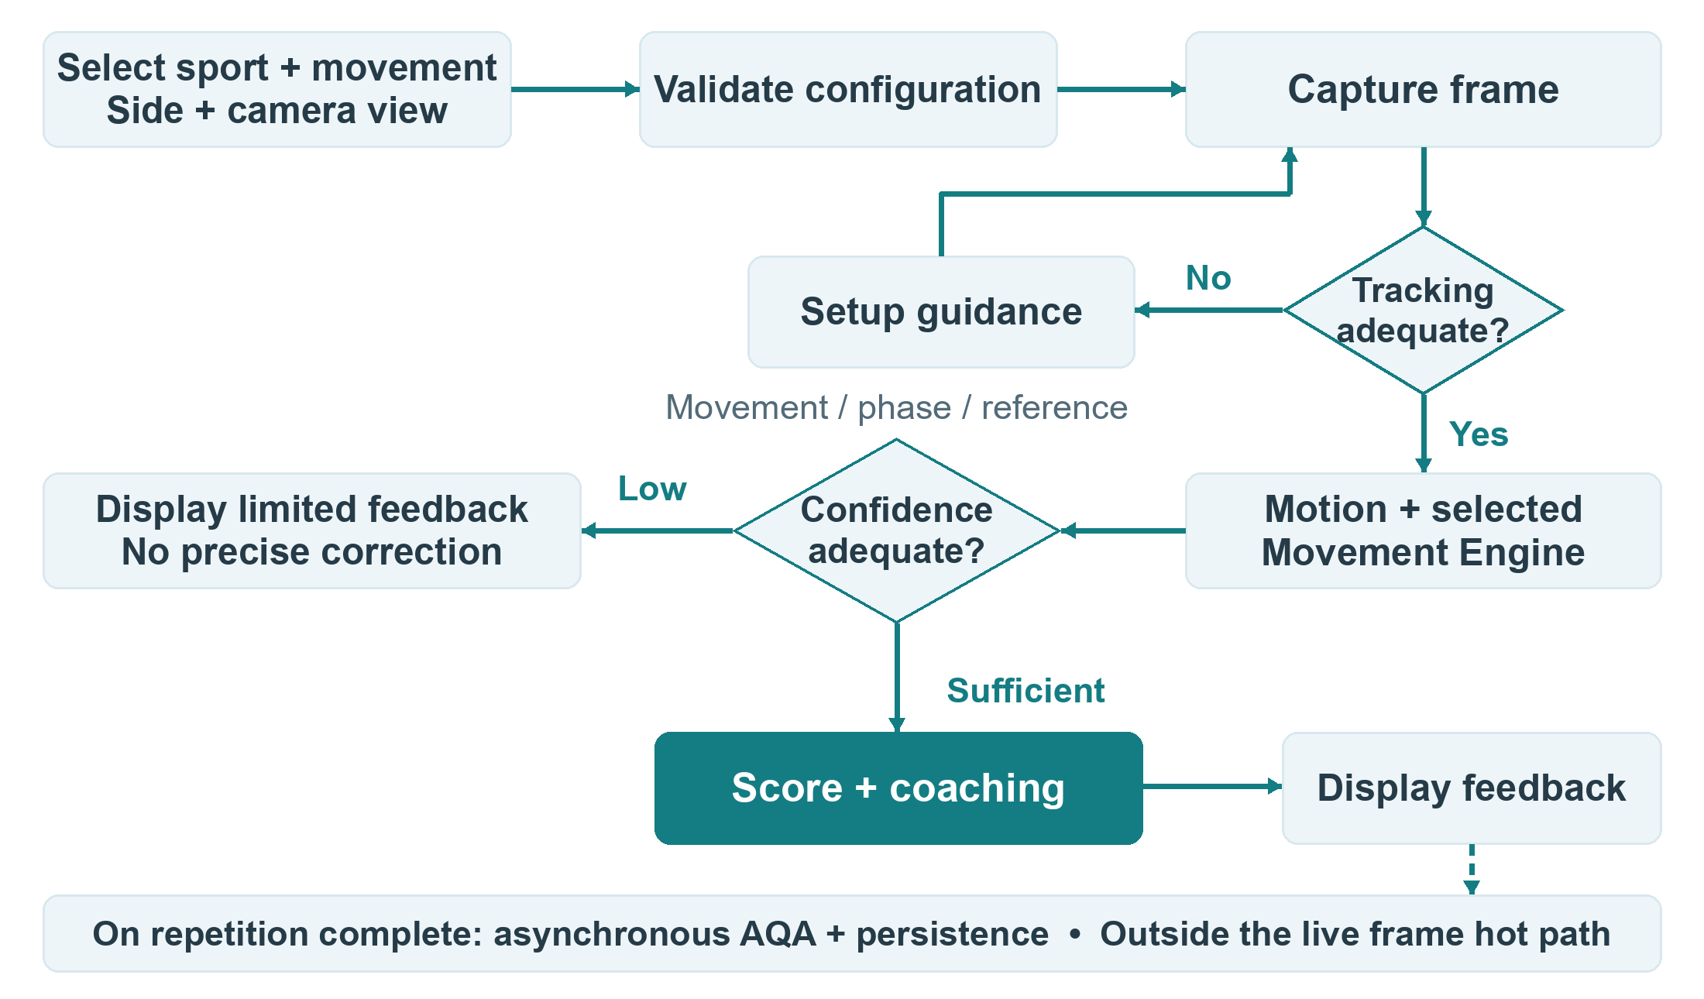
Figure 4 Live training flow with confidence gates and separate post-rep processing

Proposed failure and recovery behavior
Condition | Expected response
Unsupported or disabled sport or movement | Reject session setup with a specific reason; do not substitute another engine.
Required feature, model, or eligible reference missing | Expose the affected capability as unavailable; allow only the analysis that remains valid.
Temporary tracking loss | Suppress precise corrections; guide setup; avoid inventing a completed rep.
AI or connection interruption | Show interrupted analysis, stop presenting stale feedback as live, and apply an explicit reconnect policy.
Stop, cancellation, or duplicate completion | Finalize or cancel predictably and avoid duplicate rep records or training rewards.

These recovery details are proposed additions to the source requirements. Timeout values, reconnect behavior, invalid-rep rules, score finalization, and retry limits must be decided before implementation is accepted.

13 Real time performance
PER01. Retain the backend’s single in-flight frame and latest pending frame strategy. When a new frame arrives during analysis, it replaces the older pending frame. Completion releases the newest pending frame for processing.
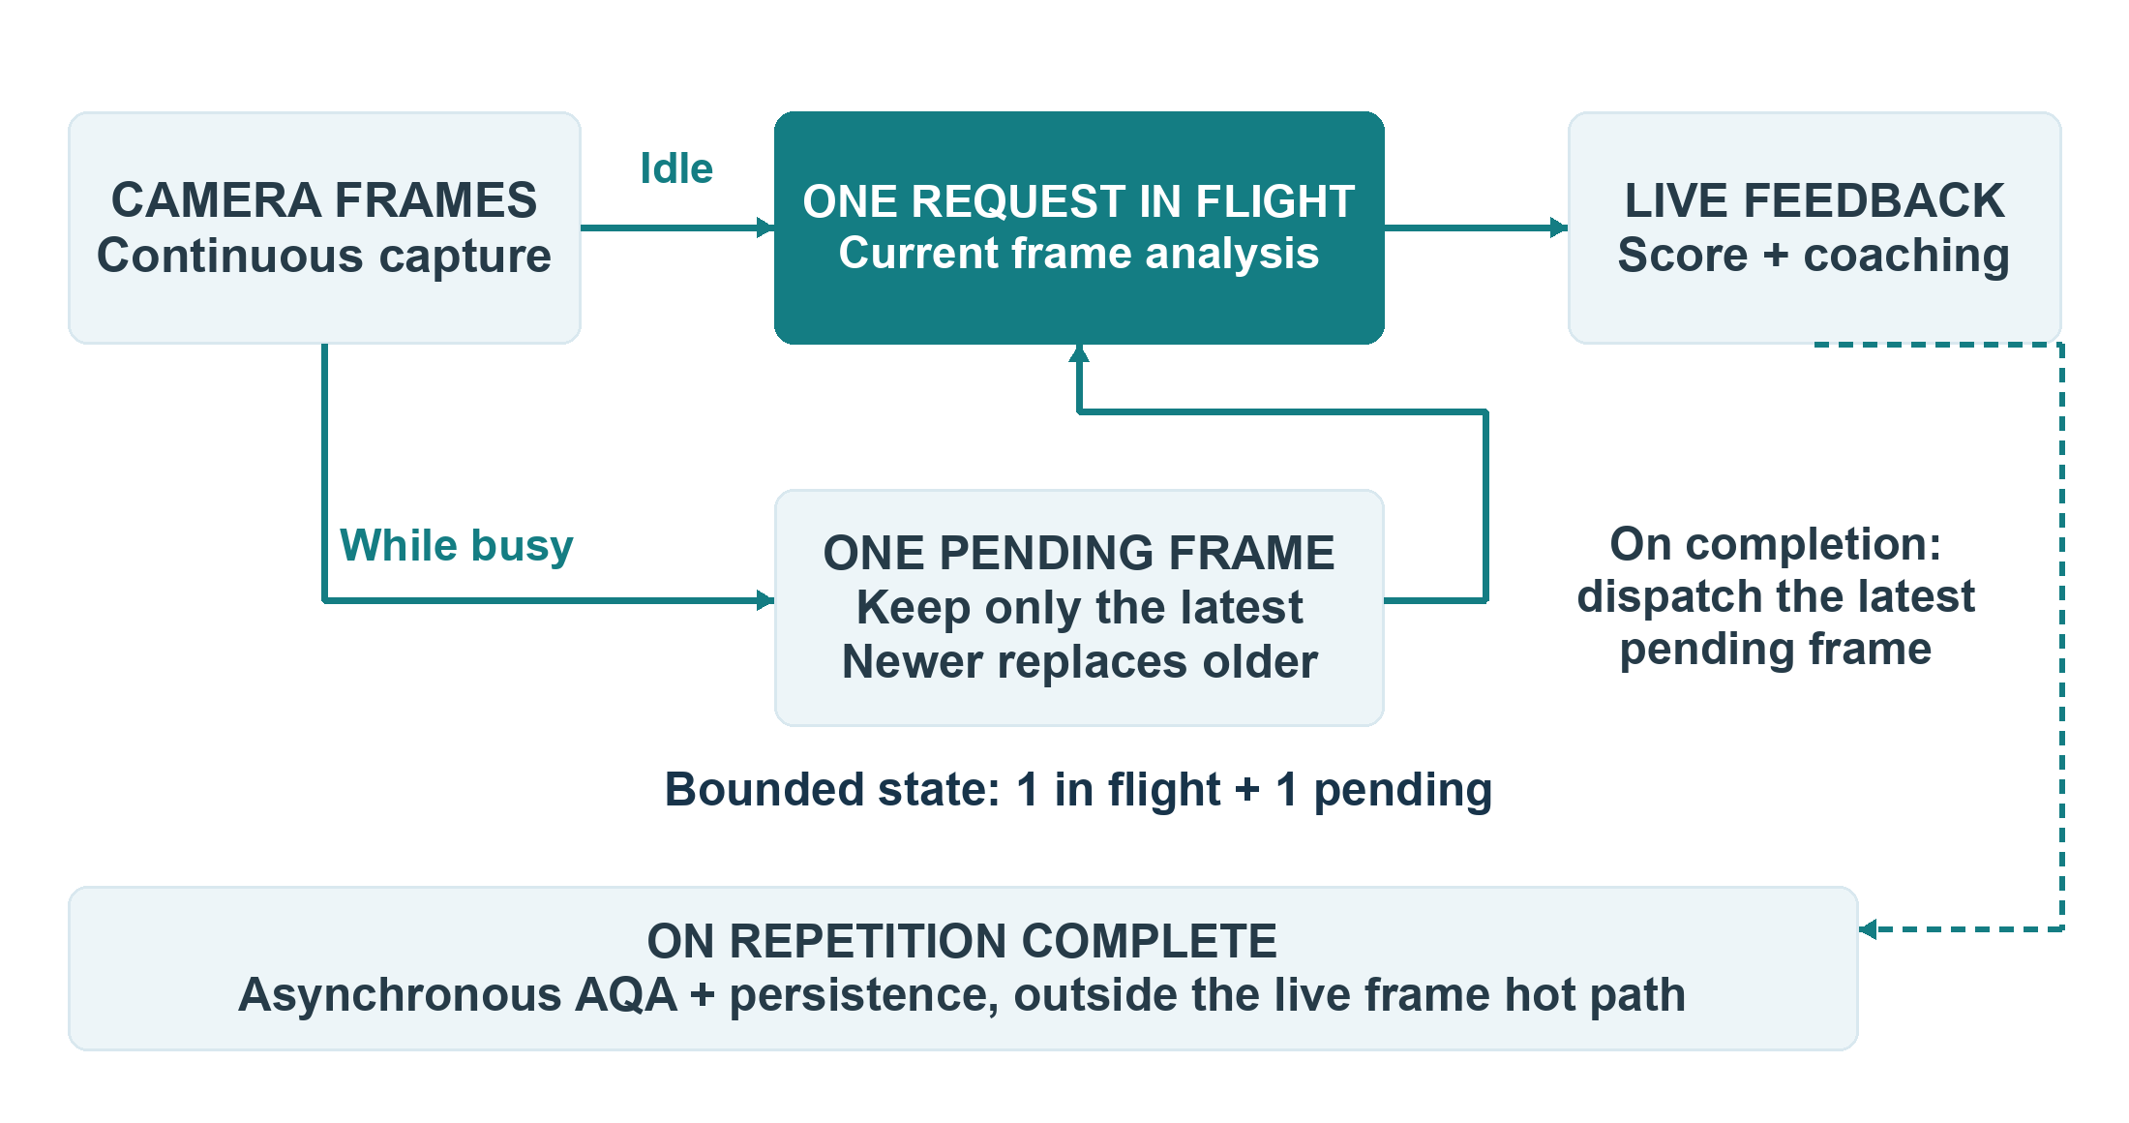
Figure 5 Bounded live frame processing and asynchronous repetition analysis
Measure | Target or constraint
AI analysis P50 | Less than 60 ms
AI analysis P95 | Less than 120 ms
Capture to displayed feedback | Less than 150 ms where the environment permits
Live queue | One in-flight frame plus the latest pending frame; no unlimited queue
Post-rep models | AQA and expensive inference remain outside the live frame path

PER02. Measure MediaPipe, network, backend relay, core motion processing, sport-engine processing, reference lookup, response serialization, and frontend rendering separately. Track end-to-end timing as well as the individual stages.
Proposed benchmark definition. Record hardware, browser, camera resolution and frame rate, network conditions, movement, dataset size, and concurrent sessions for each performance report. Select the end-to-end percentile and the acceptable regression tolerance before using the benchmark as a release gate. The targets above are requirements, not measured performance results.

14 APIs and integration
API01. Preserve the existing Socket.IO event names and extend their contracts compatibly. Session context must travel from the frontend through the backend to the selected analysis engine.
Event | Purpose and V2 contract detail
session:start | Initialize sessionId, sport, movement, analysisMode, dominantSide, and cameraView.
frame:submit | Submit the pose observation associated with the active session. Preserve frame timing, identity, and available depth.
feedback:result | Return phase, rep state, scores and confidence, issues, metrics, tracking status, and engine diagnostics.
session:stop | Stop analysis and finalize session processing according to the lifecycle policy.

Proposed V2 service endpoints
Method and path | Responsibility
POST /v2/analyze/frame | Analyze a live observation using the session’s selected engines.
POST /v2/analyze/rep | Analyze a completed trajectory and rep-level components.
POST /v2/session/start | Validate configuration and initialize analysis state.
POST /v2/session/end | Finalize analysis and release session resources.
GET /v2/sports | Discover available sports.
GET /v2/sports/{sport}/movements | Discover movements supported by a selected sport.
GET /v2/engines/status | Expose engine availability and status.
GET /v2/health | Report service health.

API02. Keep /analyze and /analyze/dynamic operational during migration. The dynamic route can delegate through LegacyDynamicAdapter to SportEngineRegistry. Move the frontend to V2 contracts after compatibility is verified.

Contract completion
Appendices A and B retain the proposed input and result shapes. Before implementation, define shared types, naming conventions, valid ranges, nullability, schema versioning, error responses, and unsupported-capability behavior. In particular, the sample result uses numeric scores and optional diagnostics, while abstention and release diagnostics require explicit representation.
Proposed clarification. Validate that the authenticated user owns the session on every session and frame operation. Reject a frame whose context does not match its initialized session; do not silently reroute it.

15 Persistence and athlete intelligence
DB01. Preserve User, TrainingSession, PoseFrame, UserStats, EnhancedStreak, Achievement, Leaderboard, and Circle. Introduce or extend Sport, Movement, MovementVersion, ReferenceDatasetVersion, RepAnalysis, MetricResult, and DetectedIssue for structured analysis. AthleteMovementProfile and MovementProgress support the later P2 personalization scope.

Repetition record
RepAnalysis should capture one completed repetition without requiring reconstruction from raw frames.
Field group | Data to preserve
Identity and context | id, session_id, rep_number, sport, movement, movement_version, reference_dataset_version
Time | start_timestamp and end_timestamp
Scores | overall_score, score_confidence, phase_scores, component_scores, trajectory_score, kinetic_chain_score, fluidity_score, aqa_score
Feedback | Structured issues and associated metrics

Proposed relationship model. A TrainingSession contains multiple RepAnalysis records; each rep references the movement and dataset versions used. MetricResult and DetectedIssue records belong to a rep. AthleteMovementProfile and MovementProgress aggregate comparable results for one athlete and movement.

Configurable frame persistence
Mode | Storage behavior
Debug | Store every analyzed frame.
Production normal | Store sampled frames, phase-transition frames, issue frames, and rep trajectories.
Research | Store complete trajectories.

DB02. Persistence mode must be configurable by environment or session. Retention duration and access policy are separate decisions; choosing a storage mode does not imply indefinite retention.

Personalization progression
Foundation work should capture structured rep metrics. P2 Athlete Intelligence can use phase scores, kinetic-chain metrics, recurring issues, average and best scores, consistency, and trends to personalize future sessions.
For example, an illustrative set of ten smash reps may contain late hip initiation in eight, low elbow position in three, and slow recovery in five. The recurring-issue layer may prioritize hip initiation. These counts are an example of aggregation, not observed athlete results.
Proposed clarification. Trends should distinguish genuine performance changes from changes in scoring policy, model, or reference version. Cross-version comparison needs a defined compatibility or recalibration rule.

16 Session state and operations
OPS01. Analysis must depend on SessionStateStore rather than directly on Python process memory. Use InMemorySessionStateStore for development and target RedisSessionStateStore for production scaling.
Each AnalysisSession holds core state, sport session, and movement session. This includes the selected engines, phase state, signal filters, trajectory, kinetic state, rep counter, issue history, and score history.

Observability and provenance
OPS02. Log session latency, frames per second, tracking confidence, selected sport and movement engines, phase transitions, reference-search time, scoring time, errors, and dropped frames. Track P50, P95, P99, throughput, AI service failures, phase confidence, and movement confidence when classification is available.
OPS03. Core and sport-engine versions must appear in foundation diagnostics. The longer-term provenance contract should identify core, sport, movement, reference dataset, model, and scoring policy versions. Dataset version recording is already required for reproducible scoring.

Proposed operational requirements
Area | Proposed implementation requirement
Session lifecycle | Define start, active, interrupted, finalizing, stopped, and expired behavior; release filter and trajectory state on termination.
Concurrency | Give each session a clear processing owner; serialize state updates and prevent duplicated rep completion.
Reconnects | Specify whether state can resume, when a new session is needed, and how stale or out-of-order frames are rejected.
Version compatibility | Validate serialized state and engine versions before restoring a session; avoid mixing incompatible state during deployment.
Access control | Authenticate session operations and enforce session ownership; restrict research data and diagnostics to authorized roles.
Data handling | Define consent, retention, deletion, access, export, encryption, and research reuse rules; exclude sensitive media and identifiers from routine diagnostics.

These additions describe implementation decisions that need review. This PRD does not assert a compliance certification or prescribe a legal retention period.

Service degradation
Proposed behavior is to expose engine and model availability through status endpoints, distinguish unavailable analysis from a valid low score, and keep transient failures observable. A failed post-rep model must not stall live frame processing. Availability targets, capacity limits, state expiry, and operational alert thresholds remain open.

17 Migration and rollout
Taekwondo is the first Sport Engine because the existing platform includes ten dynamic movements, phase definitions, reference infrastructure, trajectory scoring, AQA, and validation work. Migrate those assets before using a second sport to test extensibility.
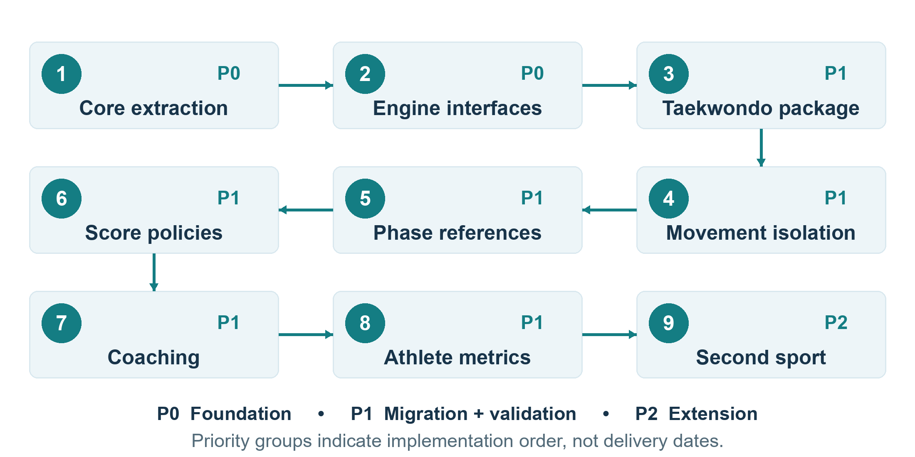
Figure 6 Migration sequence from shared core extraction to a second native sport

Migration constraints
Core extraction must preserve behavior. Introducing the engine interfaces should wrap the current pipeline without major scoring changes. Taekwondo movement definitions, weights, references, phases, and AQA then move into its package. Separate movement engines, phase-aware reference extraction, movement score policies, and coaching follow in that order.
Structured rep metrics prepare Athlete Intelligence. The second sport must use the plugin interface without modifying the core except for genuinely universal features. Its selection and delivery timing remain open.

Proposed rollout and rollback
1. Establish reproducible baseline results and versioned golden trajectories before changing routing.
2. Compare the adapter and modular implementations using the same recorded inputs and documented tolerances.
3. Enable the migrated sport for controlled validation after isolation, correctness, latency, and compatibility checks pass.
4. Expand availability after coach review and operational evidence meet the agreed gates.
5. Revert routing to the last validated engine and compatible dataset if isolation, scoring integrity, or performance fails. Preserve affected result versions for investigation.
No calendar dates or assigned delivery owners are established in this PRD. Rollout cohorts, rollback triggers, and operational ownership are proposed decisions for release planning.

18 Validation and success metrics
VAL01. Each movement engine requires unit tests, recorded trajectory tests, regression tests, and coach-reviewed athlete validation. A visually plausible output alone is insufficient evidence.

Golden movement dataset
Create a permanent, human-annotated validation set for each movement with 20 correct, 20 moderate, and 20 intentionally incorrect examples. Expand the set over time. Evaluation should measure phase accuracy, rep detection, issue detection, scoring agreement, false positives, and false negatives.
Proposed evaluation control. Keep validation examples separate from reference construction and model training where possible, and document athlete, view, dominant-side, and execution-quality coverage. This reduces the risk of measuring memorization rather than useful movement analysis.
Area | Metrics and evidence
Recognition when enabled | Precision, recall, and F1 for sport or movement classification
Phase detection | Phase accuracy and transition timing error
Issue detection | Precision, recall, false-positive rate, and false-negative rate
Rep detection | Rep-count accuracy on known trajectories
Scoring | Pearson and Spearman correlation with coach scores; mean absolute error
Reliability | Consistency across repeated similar executions and compatible capture conditions
Performance | P50/P95/P99 latency, throughput, dropped frames, and per-stage timing

Test coverage
- Unit tests cover angle calculations, trigger logic, score calculation, and reference filtering.
- Recorded trajectories assert expected phases, rep counts, and major issues.
- Regression tests identify unexpected score changes after an engine, model, policy, or dataset update.
- Athlete tests include correct execution and known incorrect executions reviewed by a qualified coach.
- Isolation tests instrument repository access and verify that unselected sports receive zero accesses.
VAL02. Define pass thresholds for accuracy, score agreement, reliability, and regression tolerance before release approval. The source specifies the measures and latency targets but does not establish numerical quality thresholds. Record the dataset versions, environment, engine versions, and review outcome with each evaluation.

19 Release acceptance
Foundation acceptance requires the following checks to pass with recorded evidence. Product, engineering, and coaching approvers and numerical quality thresholds remain to be assigned.
ID | Acceptance criterion | Evidence
AC01 | Existing Taekwondo analysis runs through TaekwondoEngine. | End-to-end session and regression results
AC02 | A common motion pipeline standardizes 2D/3D data and preserves available z. | Contract and normalization tests
AC03 | Core angles, velocities, smoothing, and confidence work independently of sport; no Taekwondo-specific logic remains in core. | Package review and unit tests
AC04 | Sport and movement references are isolated, and phase-specific matching is supported. | Retrieval tests and repository-access instrumentation
AC05 | Each Sport Engine declares movements, owns its biomechanical rules and references, supports independent versioning, and can be disabled independently. | Registry, configuration, and disablement tests
AC06 | Movement engines implement phases, rep detection, references, score policy, and coaching rules. | Movement unit tests and golden-set validation
AC07 | Scoring is configurable by movement; coaching rules are separate from raw scoring. | Policy and coaching tests
AC08 | Core and sport versions appear in diagnostics; sessions retain producing dataset versions. | Result and persistence inspection
AC09 | The existing frontend receives real-time feedback; authentication, gamification, and existing routes continue working. | Integration and compatibility checks
AC10 | Live analysis stays within agreed latency targets without material regression; AQA stays outside the live path. | Benchmarks and queue instrumentation
AC11 | Production never returns randomized AQA scores. Missing models return unavailable and null. | Missing-model test
AC12 | Low-confidence behavior abstains or limits correction, and feedback remains stable. | Confidence and noisy-input tests

Mandatory isolation scenario
Start a session with sport set to badminton in the isolation test fixture. Assert that tennis, Taekwondo, and cricket reference-repository access counts are each zero. Apply the equivalent test to every registered sport. This test validates architecture; it does not imply that badminton is already a released sport.
Release evidence package. Retain automated test results, golden-set and coach review outcomes, performance benchmarks, version manifests, unresolved exceptions, and the release decision. A failed mandatory isolation or fabricated-score check prevents acceptance.

20 Risks and open decisions
Risk | Impact | Mitigation
False precision | Precise-looking measurements may exceed reliable visual evidence. | Confidence, visibility and view gates, and uncertainty-aware feedback.
Weak reference data | Bad labels or recordings reduce scoring quality. | Coach validation, controlled capture, multiple athletes and views, and immutable versions.
Overgeneralization | One algorithm or policy misinterprets sport-specific mechanics. | Isolated Sport and Movement Engines with validated policies.
Excessive specialization | Repeated generic logic increases maintenance and divergence. | Shared motion and analysis services with explicit contracts.
Reference growth | Brute-force matching becomes too slow. | Hierarchical and phase filtering, measurements, then replaceable indexes.

Decisions required before implementation acceptance
ID | Decision | Suggested reviewing function
D01 | Product owner, technical owner, coaching reviewer, launch scope, milestones, and second sport | Product and engineering
D02 | Coordinate units, normalization, derivative timing, feature IDs, per-feature confidence, and missing-value conventions | AI and platform engineering
D03 | Confidence thresholds, score calibration, no-reference behavior, missing-component policy, and AQA finalization | AI and coaching
D04 | Required provenance fields, schema versions, error responses, and camera-view vocabulary | Platform engineering
D05 | Benchmark environment, workload, end-to-end percentile, and material-regression tolerance | Engineering and quality
D06 | Accuracy, reliability, coach-agreement, and golden-set pass thresholds | AI, quality, and coaching
D07 | Session timeouts, reconnects, serialization, concurrency ownership, and state cleanup | Backend and AI engineering
D08 | Upload formats and limits, processing experience, retention, consent, deletion, and access controls | Product and platform

Suggested reviewing functions are proposed responsibilities, not assigned people or confirmed approvals. Resolve foundation decisions before claiming release readiness; later-phase decisions can remain attached to their planned capability.

Appendix A Motion contracts
These representative TypeScript contracts preserve the proposed data shape. Shared types such as NormalizedLandmarks and Vector3 require final definitions, units, and coordinate conventions. Per-feature confidence and unavailable measurements need an explicit schema decision before implementation.
interface Landmark {
name: string;
x: number;
y: number;
z?: number;
visibility: number;
}

interface RawPoseObservation {
timestampMs: number;
frameId: string;
landmarks: Landmark[];
detectionConfidence: number;
source: { width: number; height: number; fpsEstimate: number };
}

interface MotionFrame {
timestampMs: number;
landmarks: NormalizedLandmarks;
jointAngles: Record<string, number>;
jointAngularVelocity: Record<string, number>;
jointAngularAcceleration: Record<string, number>;
positionVelocity: Record<string, Vector3>;
body: {
torsoLean: number;
shoulderRotation: number;
hipRotation: number;
shoulderHipSeparation: number;
centerOfBody: Vector3;
};
orientation: {
vertical: boolean;
facingDirection?: string;
dominantSideEstimate?: "left" | "right" | "unknown";
};
confidence: { tracking: number; visibility: number };
motionState: { active: boolean; onsetProbability?: number };
}

Feature Registry examples
Illustrative identifiers include joint_angle.right_knee, joint_velocity.right_knee, torso.rotation, hip.rotation, shoulder.rotation, center.vertical_velocity, and body.orientation. An engine declares its required subset. Standardize naming rather than maintaining parallel dotted and underscored forms.

Appendix B Session and result contracts
The example below illustrates a badminton session. It does not commit badminton to the foundation release. The analysis result is a representative contract and needs the missing-value and diagnostics decisions described in D03 and D04.
{
"sessionId": "example-session",
"sport": "badminton",
"movement": "smash",
"analysisMode": "dynamic",
"dominantSide": "right",
"cameraView": "front"
}
interface ApexAnalysisResult {
sessionId: string;
sport: string;
movement: string;
phase: { name: string; index: number; confidence: number };
rep: { count: number; completed: boolean };
scoring: {
overall: number;
confidence: number;
components: Record<string, number>;
};
issues: CoachingIssue[];
metrics: Record<string, number>;
tracking: { confidence: number; bodyVisible: boolean };
diagnostics?: {
engineVersion: string;
sportEngineVersion: string;
movementEngineVersion: string;
referenceDatasetVersion: string;
};
}
Proposed contract completion. Define CoachingIssue and unavailable-score states; make foundation-required diagnostics mandatory in the production contract. Add model and scoring-policy version fields when those components participate in analysis. The optional sample diagnostics block must not override release acceptance requirements.

Future equipment observation
interface TrackedSportObject {
type: string;
position: Vector3;
velocity?: Vector3;
confidence: number;
}

Appendix C Package and code organization
This recommended layout expresses ownership boundaries. It is a target organization, not a claim about the current repository. Package names and reference storage locations should be standardized during implementation.
apps/ai-service/app/
core/
perception/
motion/
normalization.py angles.py velocity.py
acceleration.py orientation.py motion_frame.py
signal/
one_euro.py butterworth.py derivative.py interpolation.py
features/
registry.py extractor.py
confidence/
tracking_quality.py
sports/
base/
sport_engine.py movement_engine.py contracts.py
taekwondo/
engine.py movements/ data/ models/ rules/
badminton/
engine.py movements/ data/ models/ rules/
tennis/
cricket/
analysis/
phase/ matching/ trajectory/ kinetic_chain/
scoring/ coaching/
athlete/
profiling/ trends/ weakness_detection/ personalization/

Sport and movement packages
A sport package should contain sport.yaml, movements/, references/, rules/, models/, and tests/. The manifest declares the sport, package version, supported movements, and required core features.
sports/badminton/movements/smash/
definition.yaml
phases.yaml
scoring.yaml
kinetic_chain.yaml
coaching_rules.yaml
references/
tests/
Taekwondo engines include ApChagiEngine, DollyoChagiEngine, YeopChagiEngine, DwiChagiEngine, and the remaining existing movements. Each movement receives phase definitions, references, feature weights, kinetic chain, trajectory configuration, score policy, and coaching rules.

Appendix D Illustrative policies and glossary
All values on this page are examples from the proposed design. They are not validated production weights, measured athlete performance, or acceptance thresholds.

Example movement policies
Example | Components and illustrative weights
Ap chagi score | Phase quality 0.30; trajectory 0.25; kinetic chain 0.20; extension 0.15; balance 0.10
Taekwondo feature emphasis | Hip rotation 1.8; knee extension 2.0; support knee 1.2; shoulder position 0.5
Badminton smash feature emphasis | Shoulder rotation 1.7; elbow extension 1.5; hip rotation 1.4; torso rotation 1.4; wrist or forearm signal is future work

An illustrative score can preserve overall 82, phase accuracy 87, trajectory 79, kinetic chain 66, fluidity 91, balance 84, and confidence 0.92. This is a payload example; it does not assert that these components produce 82 under the Ap chagi formula above.
{
"rule_id": "badminton.smash.hip_lead",
"condition": { "shoulder_peak_before_hip_peak_ms": "> 80" },
"severity": "medium",
"message": "Your shoulder is initiating before your hips.",
"correction": "Start hip rotation, then accelerate the shoulder."
}

Glossary
Term | Meaning in this PRD
AQA | Action Quality Assessment; a model-based evaluation of completed movement.
DTW | Dynamic Time Warping; sequence alignment used for trajectory comparison.
FSM | Finite-state machine; the configurable phase-transition framework.
ST-GCN | Spatial Temporal Graph Convolutional Network used by the current AQA capability.
MotionFrame | Sport-neutral motion features and confidence for one observed time point.
Golden dataset | Permanent annotated examples used to evaluate movement analysis.
Semantic contamination | Using another sport’s or movement’s references or rules to interpret an execution.
P50 and P95 | Latency values at the 50th and 95th percentiles of measured requests.

